Using nmap for network discovery



Ran ifconfig to find my ip address.

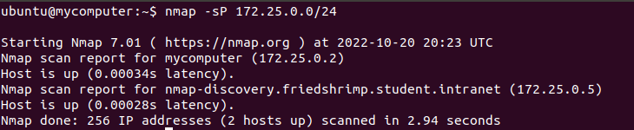

Ran a ping scan on 172.25.0.0/24 and found IP of friedshirmp server (172.25.0.5)

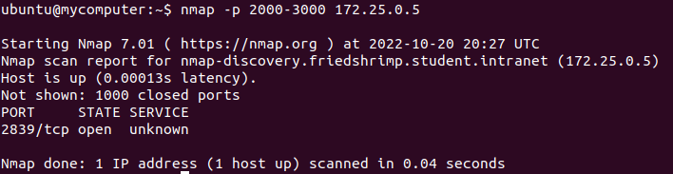

Scan ports 2000-3000 on friedshrimp server. Found 1 open port.

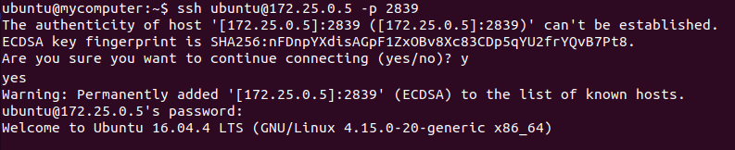

SSH Login with credentials provided from the lab.

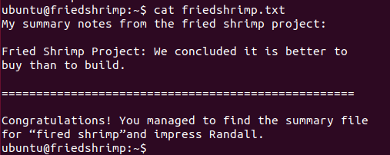

Found the .txt file on the server!